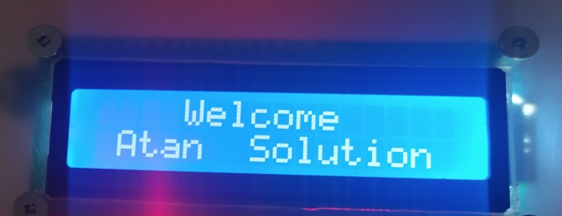How to setup

On the system

Loading to initialize sensor:

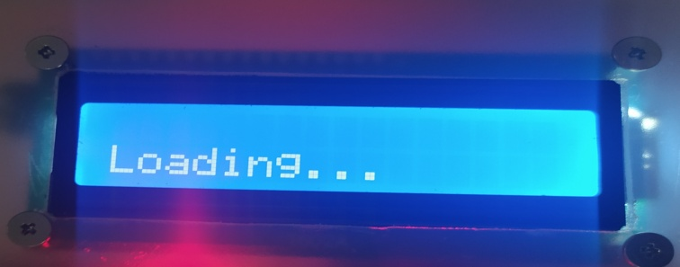

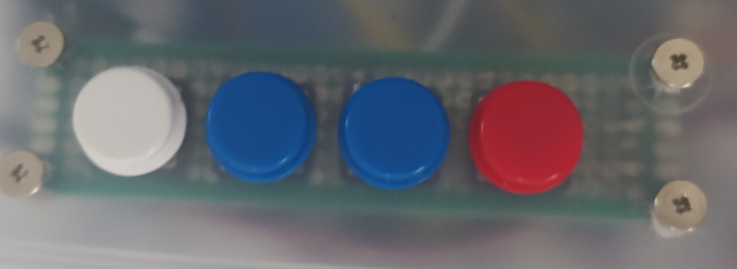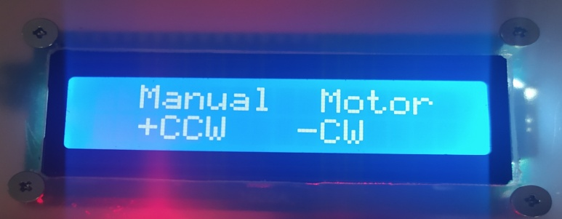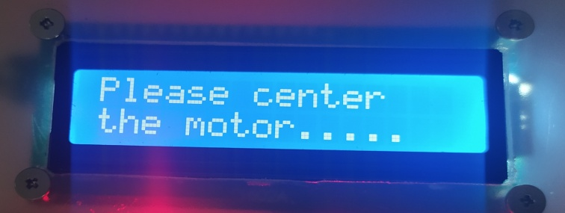The system will ask to center the motor

Press this button to Exit and Save

Press this button for Clock Wise

Press this button for Counter Clock Wise

Press the red Button to enter manual motor.

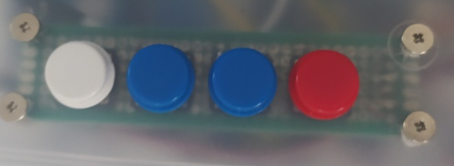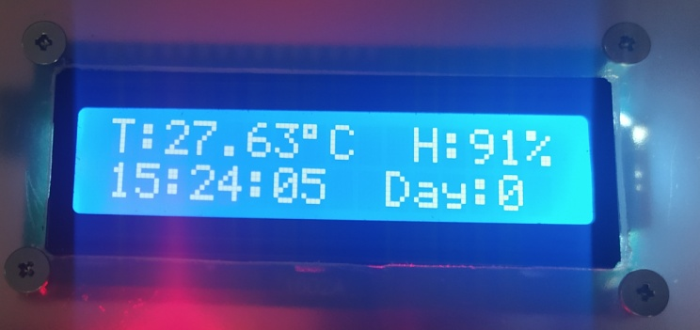Main Display

Press this button to enter settings.

Display how many days from the start of incubation.

Display current time in 24hrs mode

Display current Humidity.

Display current Temperature in Celsius

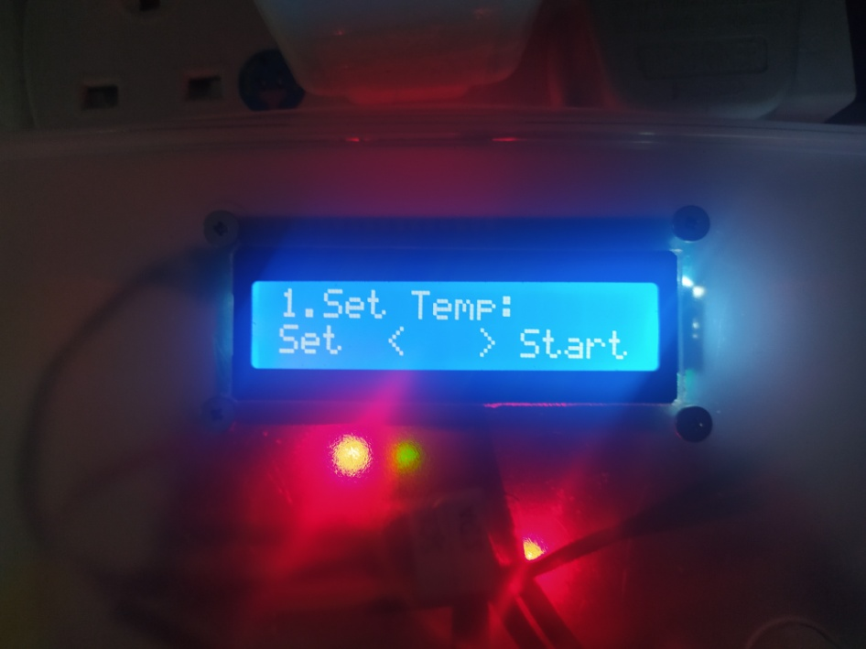Setting Mode:

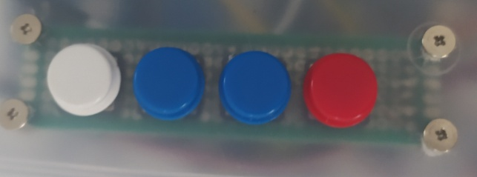

Press white button to enter the settings selected.

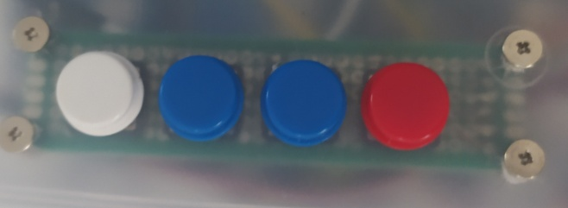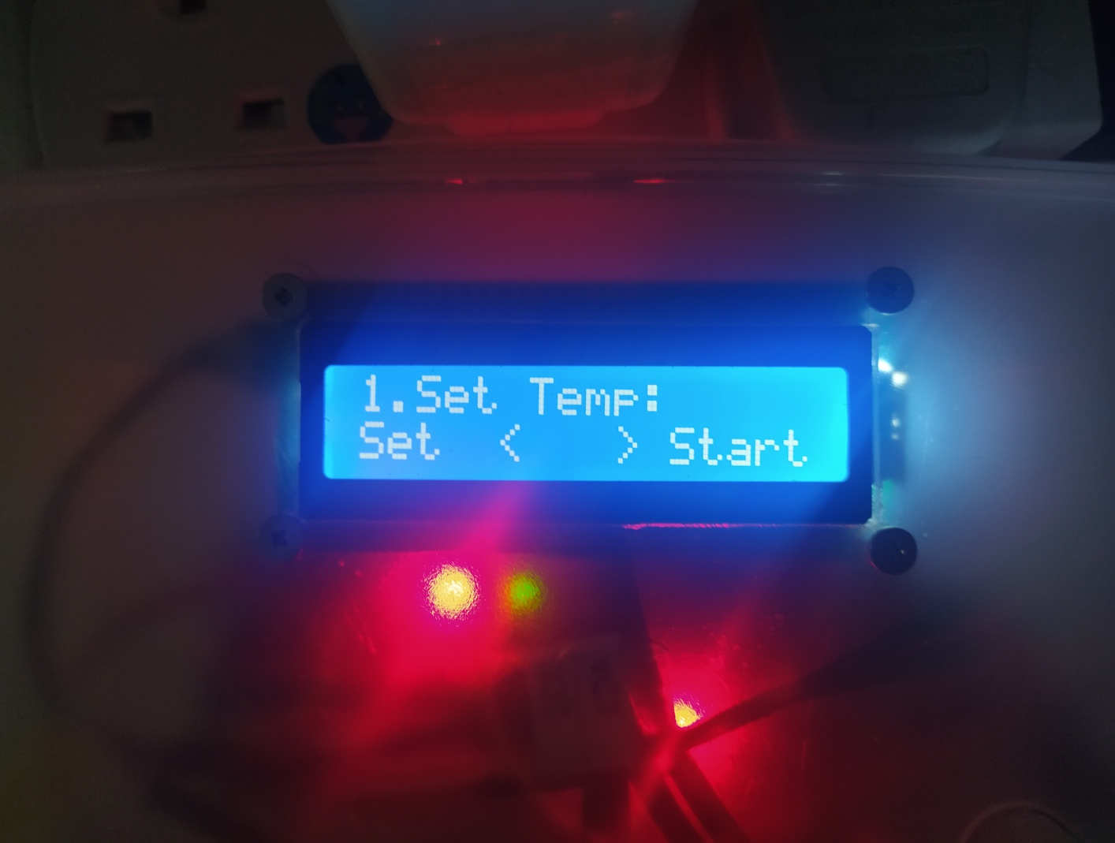

Press this 2 blue button to move from other setting.

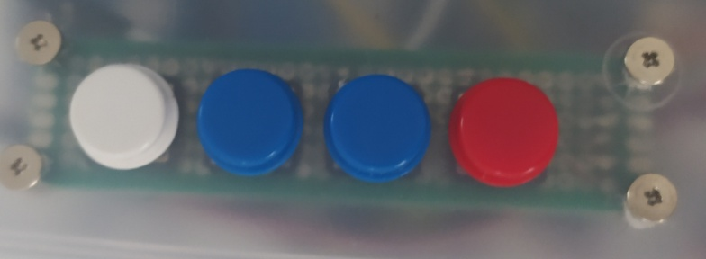

Press red button to start and back to the main display.

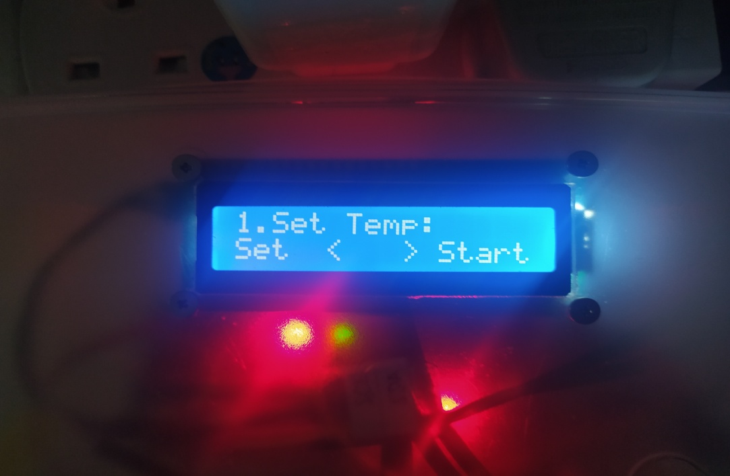

**Temperature:**

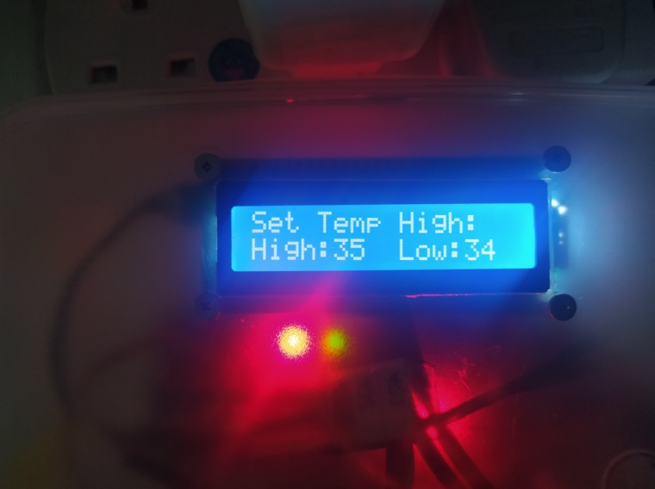

**Set Temp High:** once exceed to set temp high the bulb will cut OFF, to

low the temperature. 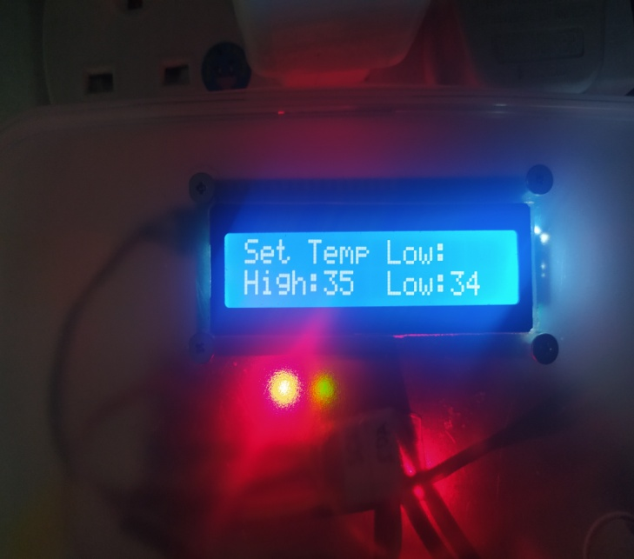

**Set Temp Low:** once below to set temp low the bulb will ON,

to increase the temperature.

Press this white button to change the set temp low and set temp high.

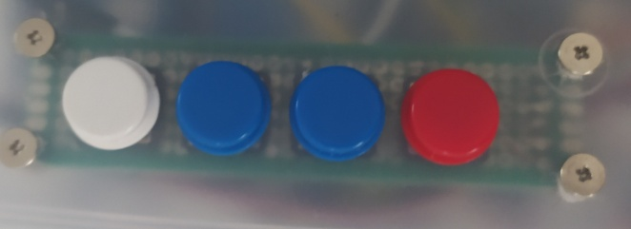Press this 2 blue button to increase and decrease the value set.

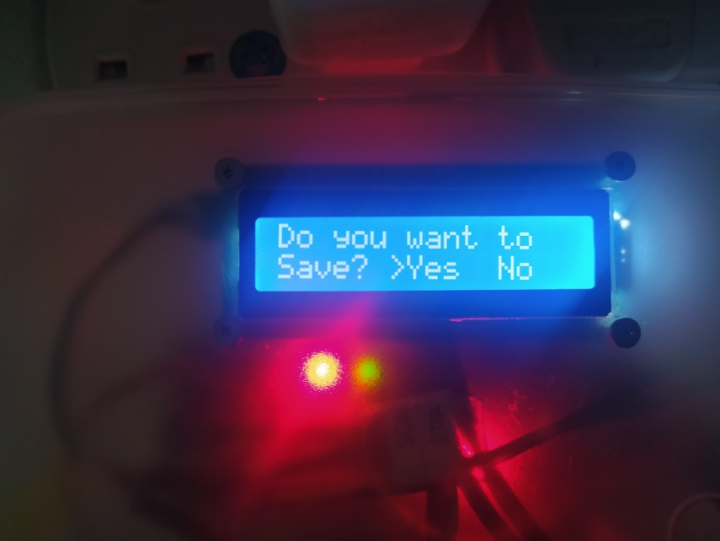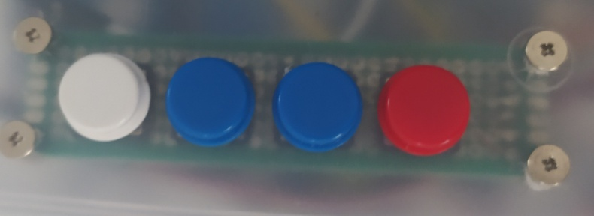 Press red button system will ask if you want to save.

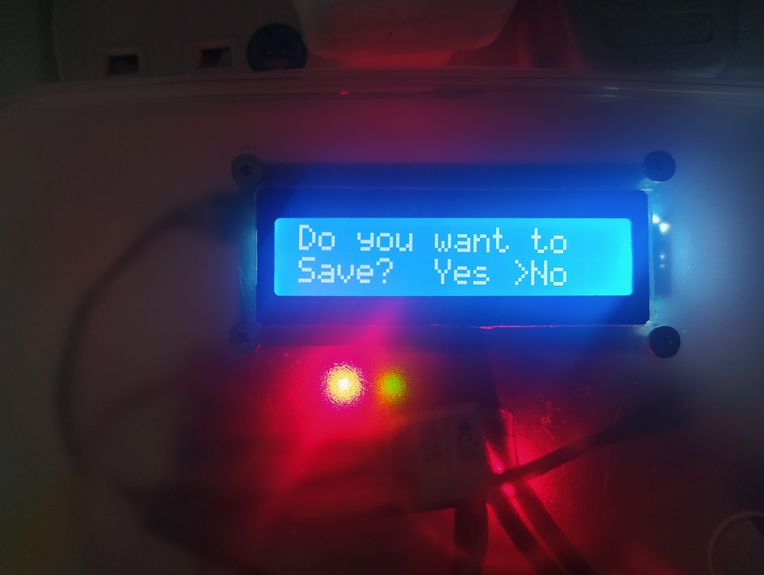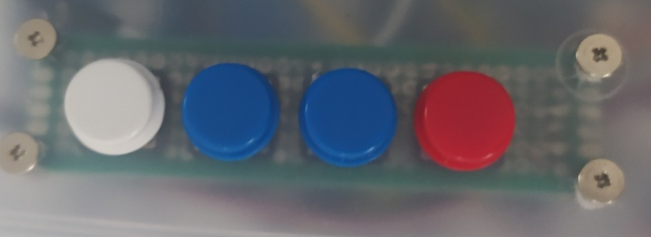

Press 2 button to change the arrow from yes to no.

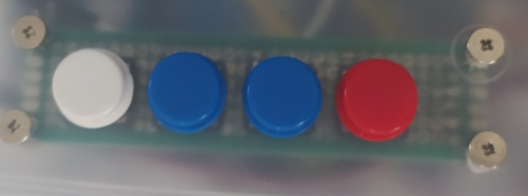

Press white button to confirm your settings. and the system will back to the setting mode.

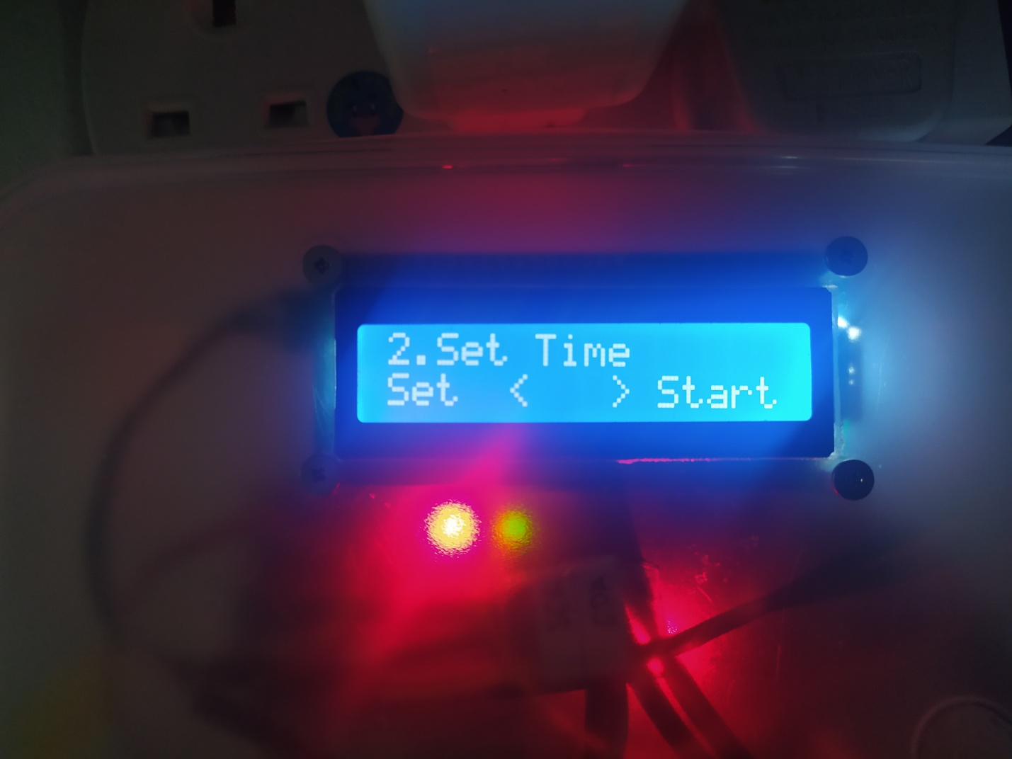

**Time**

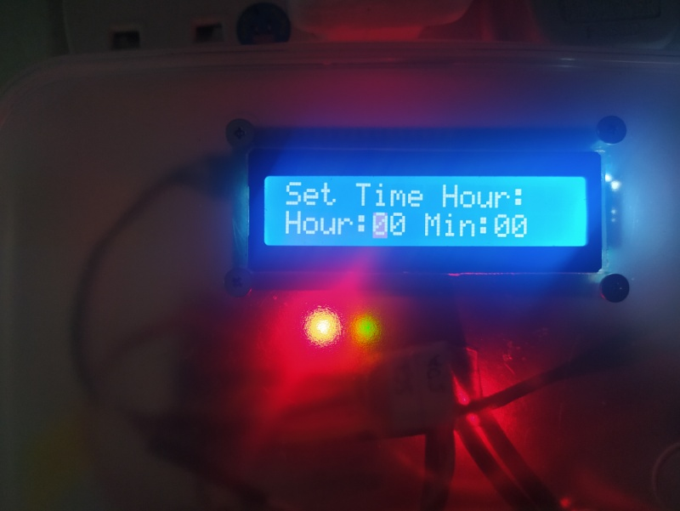

Press the white button to enter to the time setup.



Once you inside Time setting the white button will allow you to change set time hour and min, and notice the blink will appear on digit which you want to decrease and increase the value.

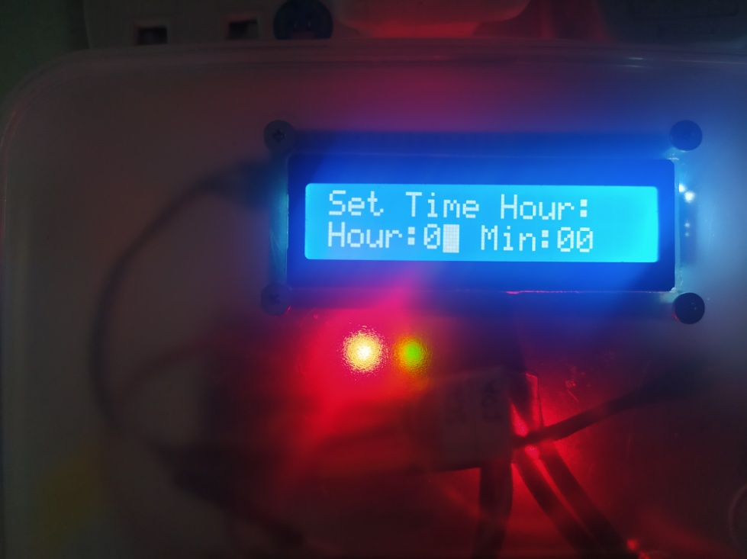

Press this to button for increase and decrease of the value.

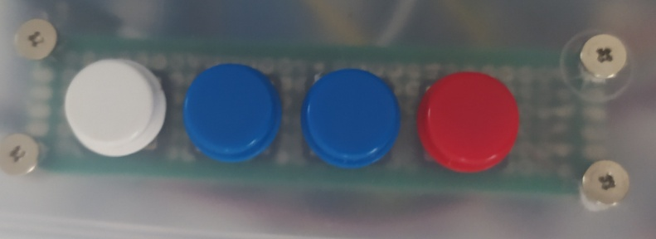

 Once you done press the red button the system will ask you if you want to save.

press white button to confirm and exit back to the setting mode.

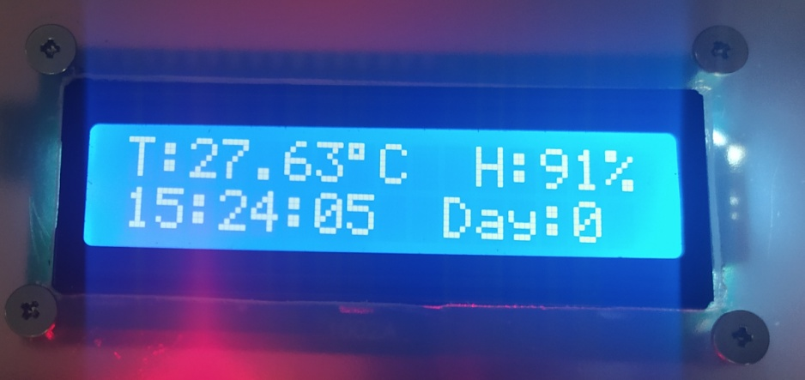**Display Main Mode:**

if you in display main mode the function of button.

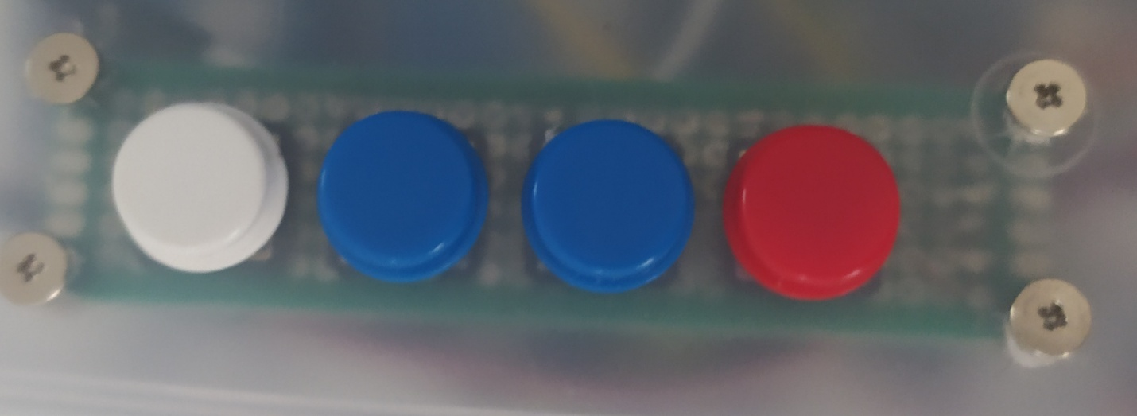

**White button:** enter setting Mode.

**1st Blue Button:** to set the date.

**2nd Blue Button:** to show the current date.

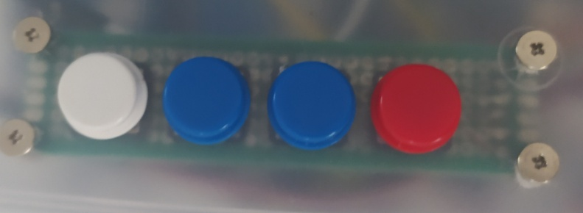**Red Button:** to enter manual turn motor.

How to change the date:

while in main display mode, press the 1st Blue button.

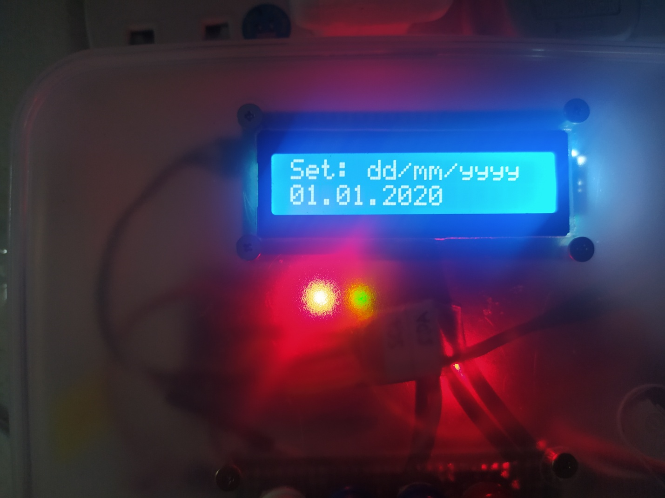

 Day Month Year Save and exit

Note: if you make mistake to edit the year the, there is no button to decrease and undo the value. the only way is to save and exit and enter again to the date set. the date will back to default 01.01.2020.

How to stop Buzzer:

The system will buzz if the current day meet the day setting. by stopping the buzzer hold the button also

to reset the day setting.



How to load the egg:

first on the system and center the tray by turning using manual motor.

Enter the desire temperature, humidity and how many hours or minute the turner will turn.

Set the time if it's not synchronous according to your time zone. the system have feature of RTC (real time clock) even the system is in power off, the date and time will continue running.

After put all the eggs, set the day and save and start. once the day reach your desire day setting the system will buzz.

**Features:**

-Power by Arduino Nano

-RTC(real time clock)

-Counter day display

-Buzzer exceed(39 Celsius).

-Buzzer exceed day.

-LCD display 16x2.

**Block Diagram:**

I2C

RTC

4 Input Button

16x2 Display

Bulb

Relay 3

Motor

Relay 1

Relay 2

Arduino Nano

Humidity Sensor

Temperature Sensor

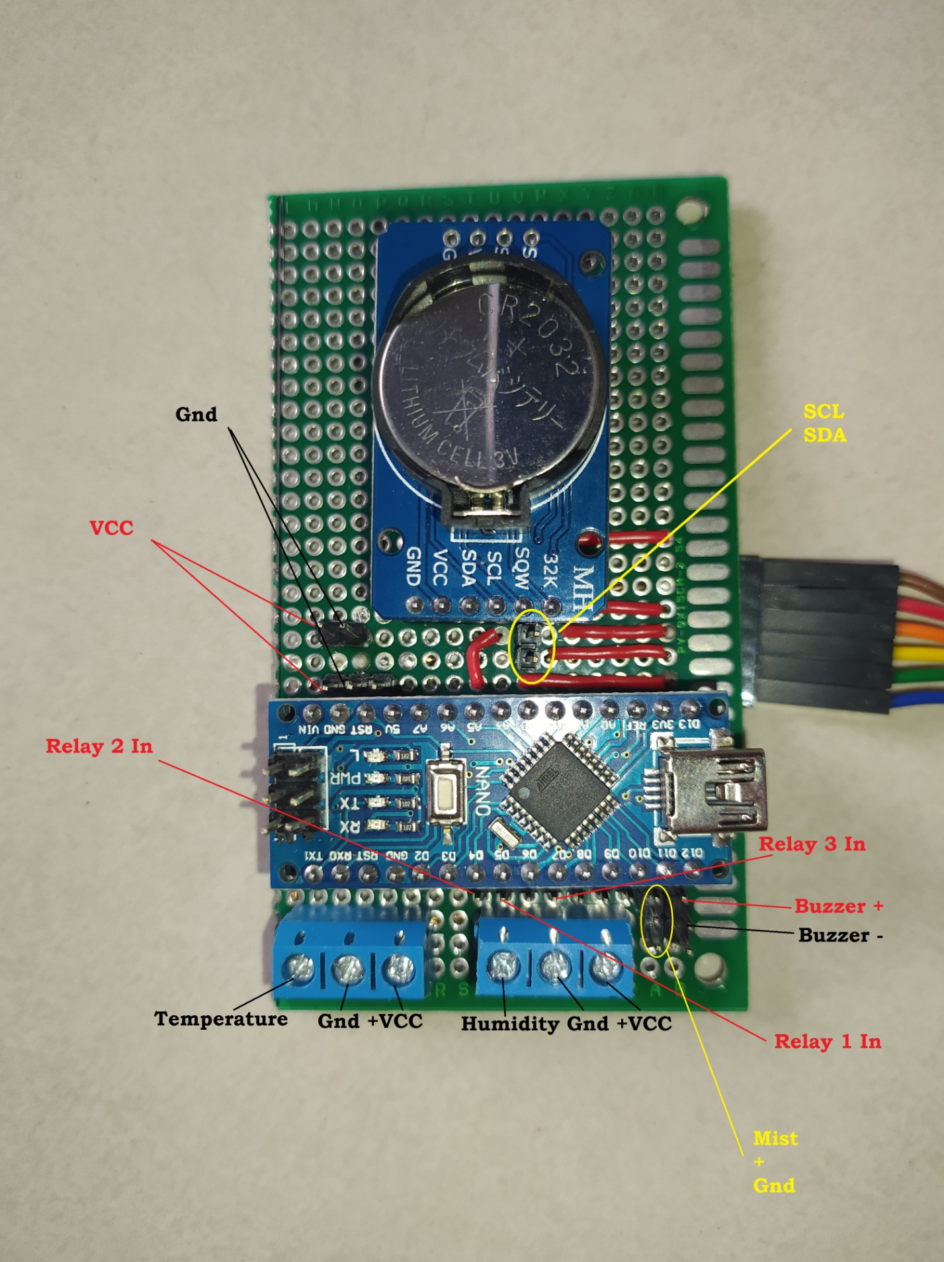

**Motor Block diagram:**

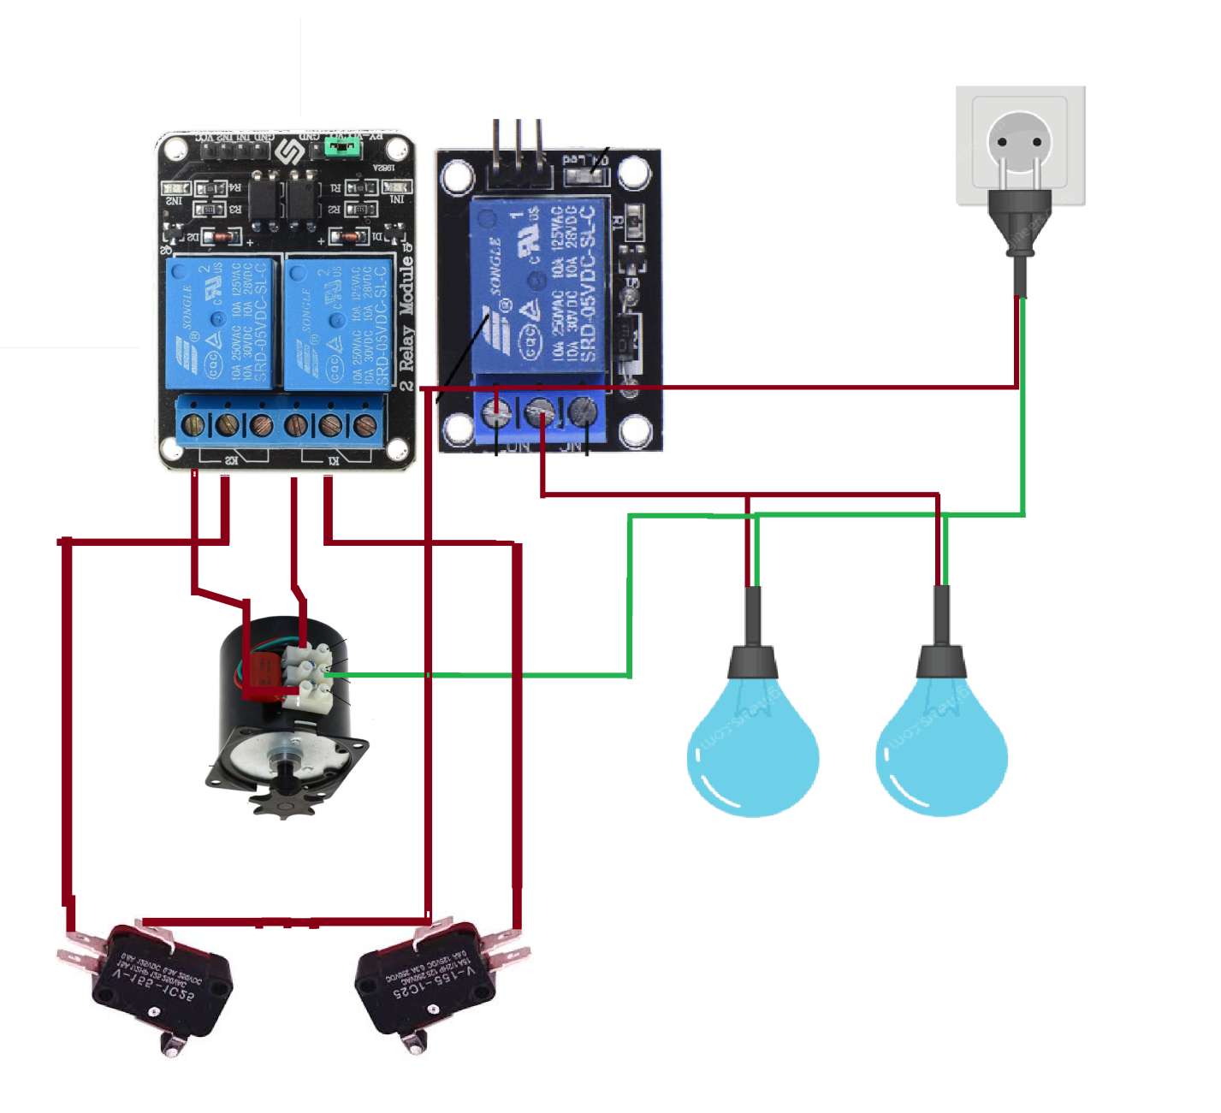

**other way:**

